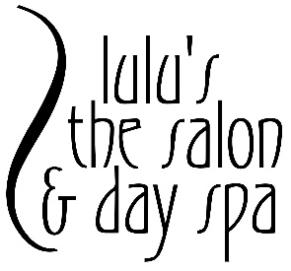
Lulu’s Bridal Recommendations

5-6 months before the wedding:
- Consult with one of our bridal party coordinators to reserve appointments for your special day

3-4 months before the wedding:
- Begin skincare regimen so your skin will be flawless for bridal portraits and your big day. Our esthetician recommends a facial three months prior.
- Impeccable eyes are also essential to looking your best. We offer eyebrow shaping and eyelash extensions. We recommend that you do not attempt wax or tweezing brows yourself. Let our professionals take care of you. Start pre-booking your eyebrow shaping and lash extension appointments.
1-2 months before the wedding:
- Want bronzed, sun-kissed skin? Start scheduling your airbrush tanning sessions
- Meet with your stylist and makeup artist for a trial run. We recommend scheduling your appointments around your bridal portraits, so you’ll be ready.
1-2 weeks before the wedding:
- Come in for your hair maintenance appointment – haircut, hair color/highlighting.
- Second and final facial for radiant skin. Allot at least seven days for the skin to heal. Depending on your skin type, it may take that long to get back to normal.
- Final waxing appointments – eyebrow shaping, and we recommend bikini wax so that you can be ready for honeymoon lingerie.
- Final eyelash extension touch-up appointment. You may come in 1 week – 2 days before your special day.
- Treat yourself to a therapeutic massage to help relax and relieve stress.
- Confirm appointments for your special day.
2 days before the wedding:
- Come in for your last airbrush tanning session.
Day before the wedding:
- Manicure and Pedicure – remember, everyone will be looking at your ring.
Day of wedding:
- Shampoo and blow-dry hair before your appointment. Hair must be clean, dry, and not flat ironed.
- Bring your headpiece or any hair accessories.
- Wear a button-down shirt or a shirt that can be removed easily.

